Technical Datasheet Smart Washroom Monitoring System
System Overview:
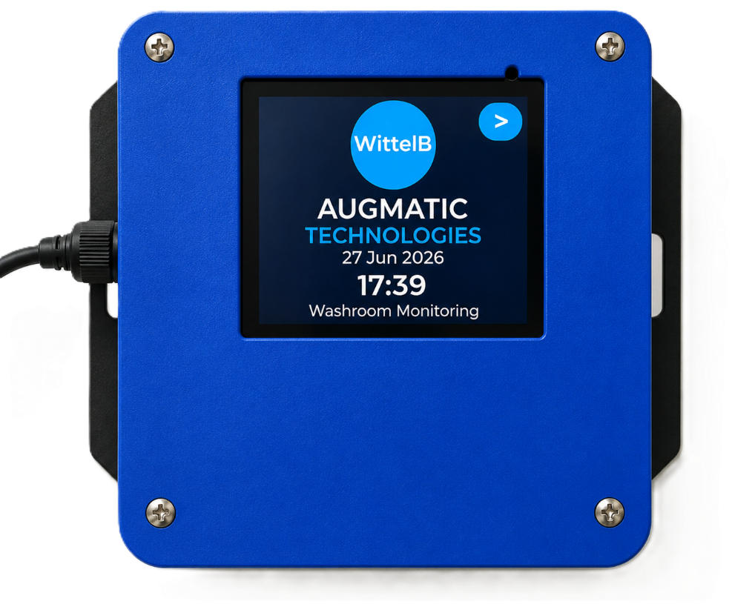
The Smart Washroom Monitoring System is a comprehensive, standalone environmental monitoring solution designed for commercial and public washroom facilities. It combines distributed wireless sensing with intelligent local alerting, real-time visualization, and IoT connectivity to continuously monitor air quality, occupancy, and system health.
System Architecture & Components:
The complete kit operates on a secure Bluetooth Low Energy (BLE) wireless network and consists of the following hardware.
- 1 of Master Gateway Unit: 1 of Master Gateway Unit: The central hub of the system. It acts as a BLE Central device to continuously receive data from the connected wireless sensor nodes while simultaneously functioning as a Wi-Fi gateway to provide real-time visualization, local data logging, alarm management, and upstream communication to cloud platforms, Building Management Systems (BMS), or facility monitoring applications.
- 1 – 8 of Wireless Sensor Nodes: The kit supports up to eight battery-powered wireless sensor nodes. Each node continuously monitors NH₃ (Ammonia), H₂S (Hydrogen Sulfide), and human occupancy while communicating with the Master Gateway over Bluetooth Low Energy. Each node incorporates local audio and visual alarms, battery status monitoring, and a reset/acknowledgement button for local alarm handling.
Hardware Protection & Core Features:
The system is housed in industrial enclosures designed for reliable operation in demanding indoor environments. The Master Gateway features an integrated touch display with intuitive visualization, while each wireless sensor node is optimized for ultra-low power battery operation. Built-in audio and visual alarms provide immediate local notification, while secure BLE communication ensures reliable wireless connectivity between the gateway and sensor nodes.
Sensor Specifications
 | NH₃ Sensor | H₂S Sensor
Sensing Element | Electrochemical | Electrochemical
Target Gas | Ammonia (NH₃) | Hydrogen Sulfide (H₂S)
Detection Range | 0 – 100 ppm
Accuracy | ±1 ppm or ±1%
Detection Accuracy | ~90%
Response Time | Less than 3 seconds
Warm-up Time | 90 Seconds

Sensor Node :–
Dimensions 85 mm L x 108 mm W x 36 mm H
Power 12/24V DC / Battery 3.7 V Nominal
Operating Temperature 0 – 60° C (32 ~ 140°F)
Storage Temperature -20 - 70° C (-4 ~ 158°F)

Storage Humidity 5 ~ 95 % RH, non – Condensing

Certifications

Master Unit :–
Dimensions 98.5 mm L x 122.7 mm W x 36 mm H
Power 5V DC Type C
Operating Temperature 0 – 60° C (32 ~ 140°F)
Storage Temperature -20 - 70° C (-4 ~ 158°F)

Storage Humidity 5 ~ 95 % RH, non – Condensing

Certifications
Local HMI Dashboard & Visualization:
The Master Gateway Unit features an intuitive, interactive touch display that provides operators with a comprehensive real-time overview of all connected wireless sensor nodes. The dashboard enables quick identification of air quality, occupancy status, people count, battery status, and overall system health for every monitored washroom.
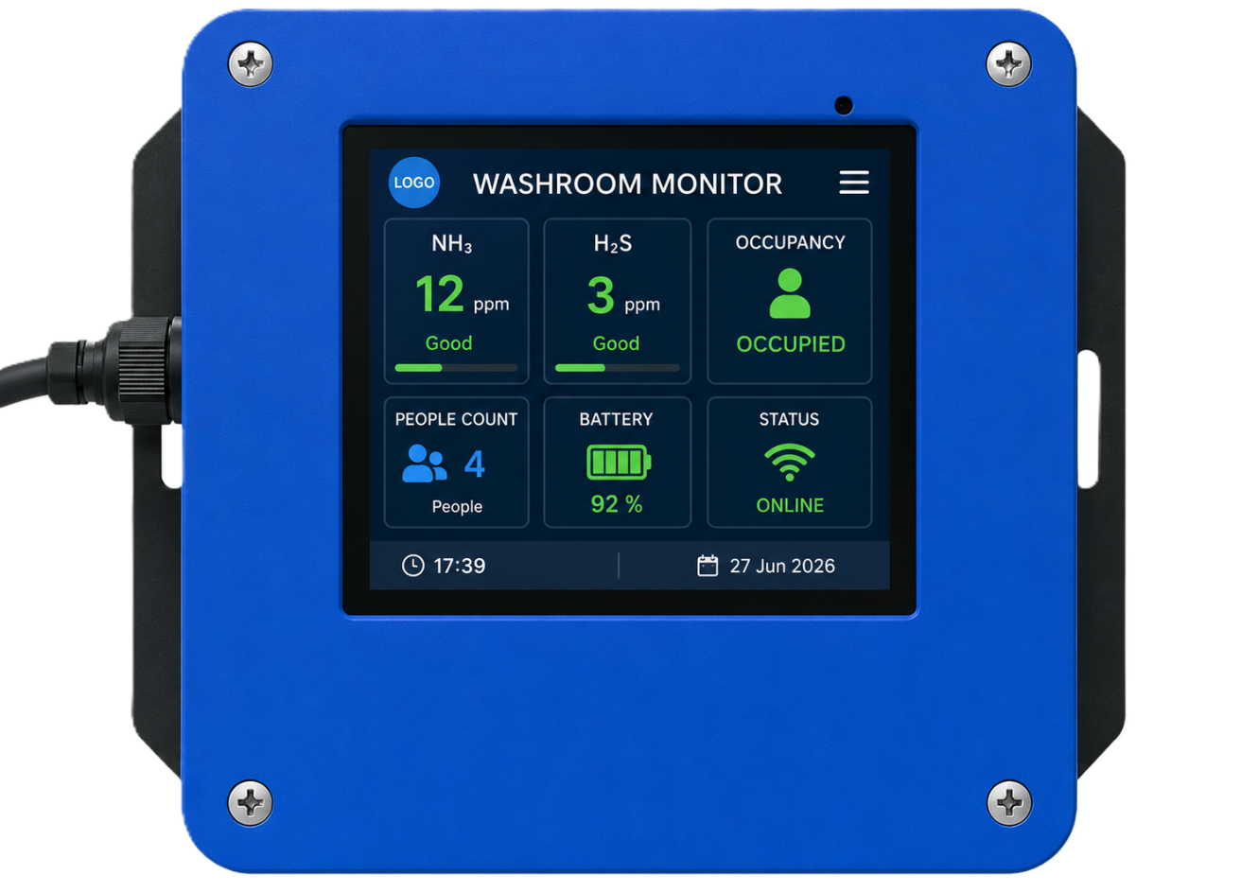
Interactive Touchscreen Dashboard:
- High-Level Overview: The home screen acts as the "Main Control Panel," providing quick-glance status of up to 8 Wireless Sensor Nodes (SN1 through SN8). Each node displays its communication status (Online/Offline), current occupancy status, and alarm indication, allowing operators to instantly identify any washroom requiring attention.
- Detailed Sensor View: Tapping on any active Sensor Node block (e.g., SN1) opens a detailed monitoring screen displaying the real-time NH₃ concentration, H₂S concentration, occupancy status, people count, battery level, and wireless signal strength (RSSI) for the selected washroom.
- Label Customization: To make monitoring as intuitive as possible, users can rename the default "Sensor Node x" labels to reflect their actual installation locations (for example, "Ground Floor - Washroom A," "First Floor - Ladies," "Office Block," etc.).
- Historical Data & Trends: The Master Gateway stores historical sensor data and provides graphical trends for NH₃ and H₂S concentration levels, occupancy duration, and people count, enabling facility managers to analyze washroom usage patterns and air quality over time.
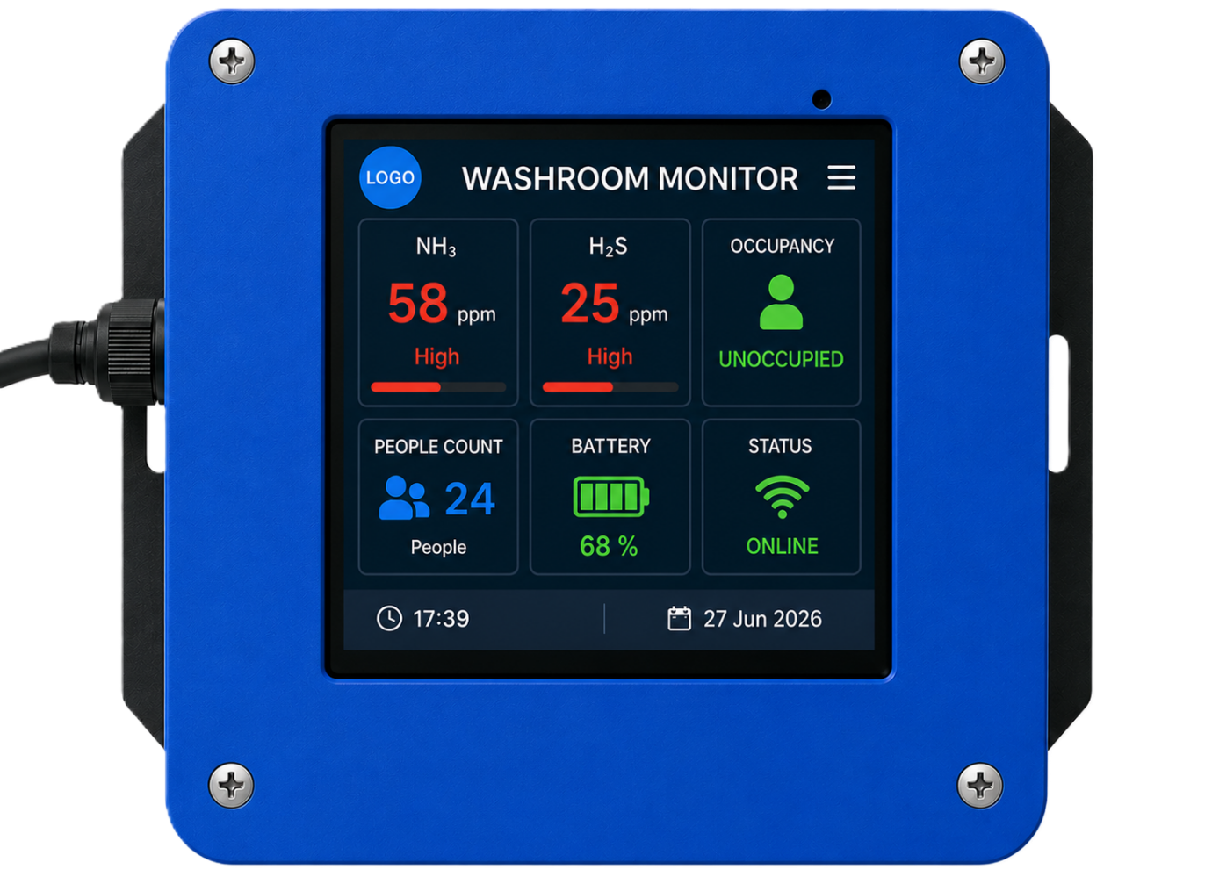
Critical Alarm & Acknowledgment System:
- Multi-Tier Alerts: If the NH₃ or H₂S concentration exceeds the configured safety threshold, the corresponding Wireless Sensor Node immediately enters an alarm state. The integrated Red LED and buzzer on the Sensor Node are activated to provide immediate local audio and visual indication, alerting nearby personnel to poor air quality. Simultaneously, the Master Gateway displays the alarm status and identifies the affected washroom.
- Alarm Acknowledgment (Snooze): Each Wireless Sensor Node is equipped with a dedicated Reset/Acknowledgement button. Once personnel have attended to the washroom condition, pressing the button acknowledges the alarm by temporarily silencing the buzzer while maintaining the alarm indication and event status on the Master Gateway for operator awareness.
- Safety Re-trigger Logic: If the NH₃ or H₂S concentration remains above the configured threshold after the alarm has been acknowledged, the Sensor Node automatically reactivates the local buzzer and Red LED, ensuring that unsafe air quality conditions continue to be indicated until normal operating conditions are restored
Flexible System Configuration:
The system is designed for both local and remote management. Users can fully customize the NH₃ and H₂S alarm thresholds, occupancy parameters, people count settings, and alarm behavior directly through the local touch display, or configure them remotely via the integrated Wi-Fi interface. This flexible configuration enables the system to be optimized for different washroom environments and operational requirements.

Integrated Wi-Fi Configuration & IoT Telemetry:
- Unlocking advanced flexibility for facility managers and maintenance personnel, the Master Gateway Unit is equipped with an integrated Wi-Fi module to simplify initial deployment and ongoing maintenance. By connecting wirelessly via a smartphone, tablet, or laptop, operators can quickly access the system's configuration interface without requiring physical serial connections. This local wireless accessibility allows effortless sensor node naming, alarm threshold configuration, occupancy settings, and system diagnostics directly from the installation site.
- Beyond local configuration, this Wi-Fi capability transforms the Smart Washroom Monitoring System into a fully integrated IoT solution capable of powerful remote telemetry. Utilizing lightweight MQTT protocols over the wireless network, the Master Gateway securely publishes real-time NH₃ concentration, H₂S concentration, occupancy status, people count, battery status, and alarm events to cloud-based dashboards or facility management platforms. This seamless IoT integration provides continuous visibility into washroom conditions, enabling proactive maintenance, improved hygiene management, and faster response to poor air quality events.

Contact us: -
Augmatic Technologies Pvt. Ltd.,
Plot no 6, Shah Industrial Estate II,
Kotambi,
Vadodara – 391510.
Email – Sales@wittelb.com
Support: support@wittelb.raiseaticket.com / +91 94038 92805

